**Thinking in Shortest Path Lengths**

Structural paths that are shorter or are composed of fewer steps generally allow signal transmission with less signal loss or noise1. This is the telephone effect.

In terms of global processing, the centrality of a network plays an important role in the characteristic global path length:

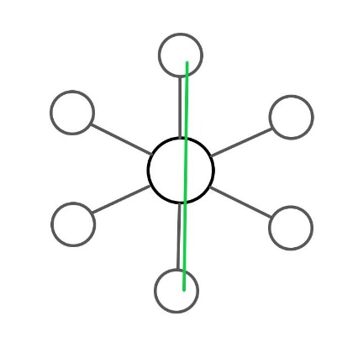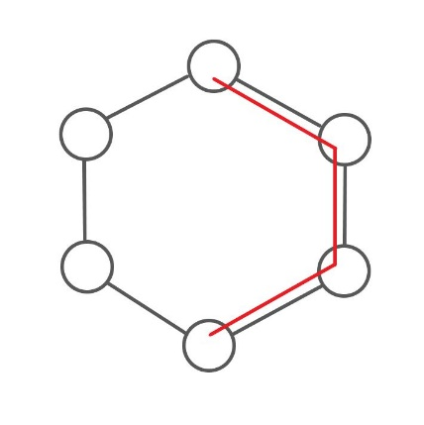

The central network of consciousness is the Default Mode Network2 (mPC and in particular PCC), which is the neurological basis for the self, handling *Autobiographical information, Self-reference, Emotion of one's self, Theory of mind, Empathy, Moral reasoning, Social evaluations and categories, and projecting one’s self through time in memories.*

The function of this network can be summed up in general terms as *entity processing*.

It’s also apparent that the way in which one chooses to think changes the structural connectivity of the brain in terms of how that information is shaped mentally3.

It comes from these first two things together, the question of how to think in terms of producing the shortest path lengths comes from centering thought, which happens to be from the central network outward, which with the DMN means *entity* -outward.

This picture depicts the ideation of self in the context of the most immediate relative organization of scientific information (so then node structure) from the self-outward:

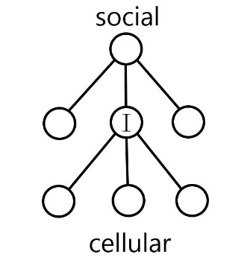

It depicts the relationship between society, people, and cells, centered around present entity.

This offers a structural locus which branches a short path between science upward and downward in scale; sociology and cellular biology respectively. And there is a pattern which reveals itself in doing so:

There is a repeating pattern of the functional organization of matter between layers.

In practical language: “Society is made up of people which are made up of cells, and so societies get their characteristics from people who get their characteristics from cellular organization.”

Which goes like this:

Central Processing: A *cell* has nuclei, a *human* has a brain, *society* has a government.

Boundaries: A *cell* has a membrane, a *human* has skin, *society* has borders.

Resource distribution: A *cell* has endoplasmic reticulum, a *human* has a circulatory system, *society* has transportation networks.

And so forth for every function there is to the point that functions can be inferred between them. Aside from highlighting the benefits of staying present minded when engaging in combinatorial concept processing with this understanding established in the background, there are several benefits to modeling this way:

This structural understanding of the shape and function of life allows for *entity* to be placed at the center of the fields of all sciences, taking advantage of the centrality of the physical network which handles the task. ‘Upward, so to speak, to the social level, is sociology, law, economics, and so forth. ‘Downward’ is cellular biology, chemistry, physics, or something like that. Math is ubiquitous across them. With the self in the middle providing the shortest path between scales. Everyone does this naturally to some extent. The point here is to realize the centrality of the PCC with the effort by the mPC to structure the information neurestheticly, which is to think in terms of how the brain is shaped.

Further benefit and insight come from this pattern in drawing analogy between fields. ‘As below, so above’; if I have a mind because my cells work together and communicate, then society does in fact have a collective mind because we act like cells working together and communicating. To deny the existence of a collective mind, is to deny the logic which produces our own minds. The function follows the form.

In conclusion, placing the self in the conception of the world as it is a collective and an aggregate is the most efficient way to model the empyreal world because that is how the world is in fact shaped, doing so respects the natural architecture of the brain, while facilitating presence across the most fields of information at once with the least expenditure of energy or loss of presence in abstraction. Given the metabolic rate of the PCC4, it has higher capacity than normal, so economizing for this area in terms of center of focus should pay proportionately high dividends for brain development in the same way being ambidextrous could corticicortically5.

1. Olaf Sporns, "Networks of the Brain", [MIT Press](https://en.wikipedia.org/wiki/MIT_Press), 2010, [ISBN](https://en.wikipedia.org/wiki/ISBN_(identifier)) [0-262-01469-6](https://en.wikipedia.org/wiki/Special:BookSources/0-262-01469-6) pg. 14

2. <https://en.wikipedia.org/wiki/Default_mode_network>

3. [gestures broadly at the sea of self-improvement books available now]

4. <https://en.wikipedia.org/wiki/Posterior_cingulate_cortex>

5. https://1drv.ms/w/s!AmBd8vhYiXLGl0VK_JR7QEbmGGFJ?e=t9pBdX